**Starting mysql using below command**

Sudo service mysqld start

mysql --user=root --password=root

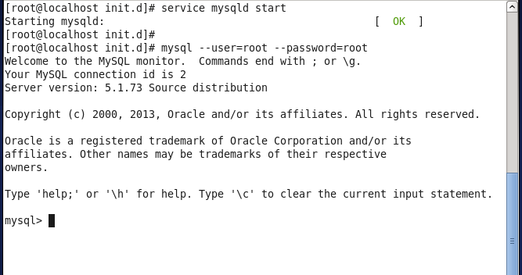

Selecting a database: use testdb;

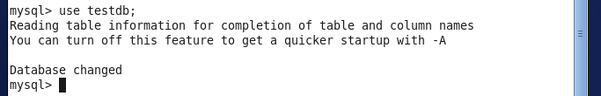

**Exporting obtained data from “TASK1”**

Creating table for Task1

CREATE TABLE task1 (

count int(10));

Creating the count column to store the no of complaints

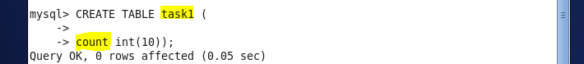

Using below statement exported the result to mysql from HDFS

sqoop export --connect jdbc:mysql://localhost/testdb --username root --password root --table task1 --export-dir /project1/output/output1/ --m 1 --driver com.mysql.jdbc.Driver

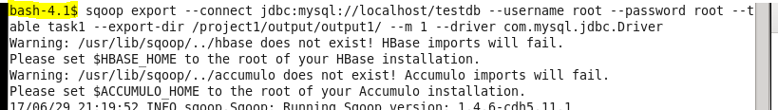



**Output:**

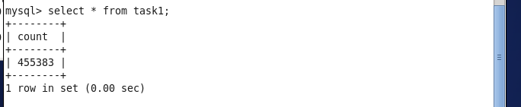

**Exporting obtained data from “TASK2”**

CREATE TABLE task2 (

count int(10));

Creating the count column to store the no of complaints

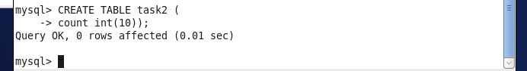

Using below statement exported the result to mysql from HDFS

sqoop export --connect jdbc:mysql://localhost/testdb --username root --password root --table task2 --export-dir /project1/output/output2/ --m 1 --driver com.mysql.jdbc.Driver

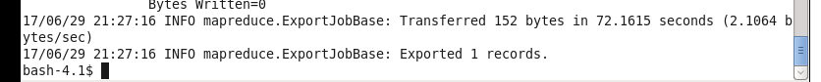

**Output:**

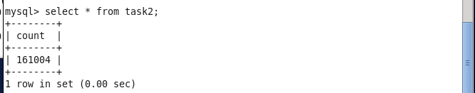

**Exporting obtained data from “TASK3”**

CREATE TABLE task3 (

company_name varchar(60),

count int(10));

Creating the name and count column to store the company name and no of complaints registered

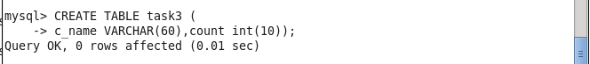

Using below statement exported the result to mysql from HDFS

sqoop export \

--connect jdbc:mysql://localhost/testdb \

--username=root \

--password=root \

--table task3 \

--export-dir /project1/output/output3 \

--input-lines-terminated-by '\n' \

--input-fields-terminated-by '\t' \

--input-optionally-enclosed-by '\"' \

--driver com.mysql.jdbc.Driver



Result:

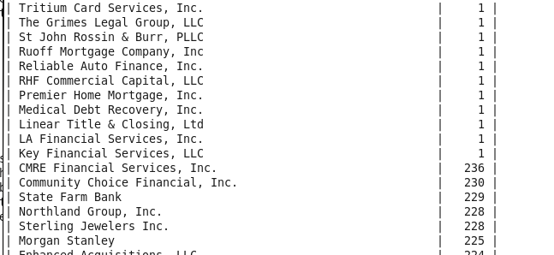

**Exporting obtained data from “TASK4”**

CREATE TABLE task3 (

count int(10));

Creating the count column to store the no of complaints



Using below statement exported the result to mysql from HDFS

sqoop export --connect jdbc:mysql://localhost/testdb --username root --password root --table task4 --export-dir /project1/output/output4/ --m 1 --driver com.mysql.jdbc.Driver

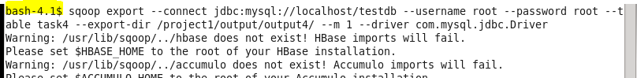



**Output:**

